**JAD #2 Meeting Agenda**

When & Where: February 24th, 2022 ~ 1:00pm - 2:00pm @ Zoom

Attendees: Dr. Jared Macshane, Dr. Shaunn-inn Wu, Sushi Team



____________________________________________________________________________

**Members:**

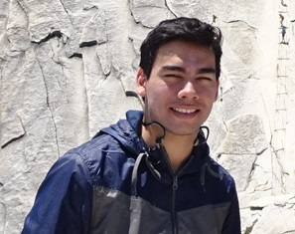

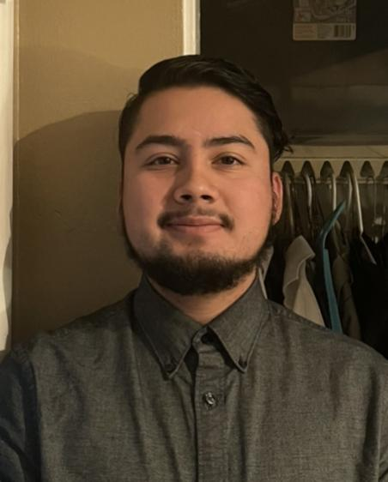

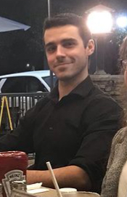

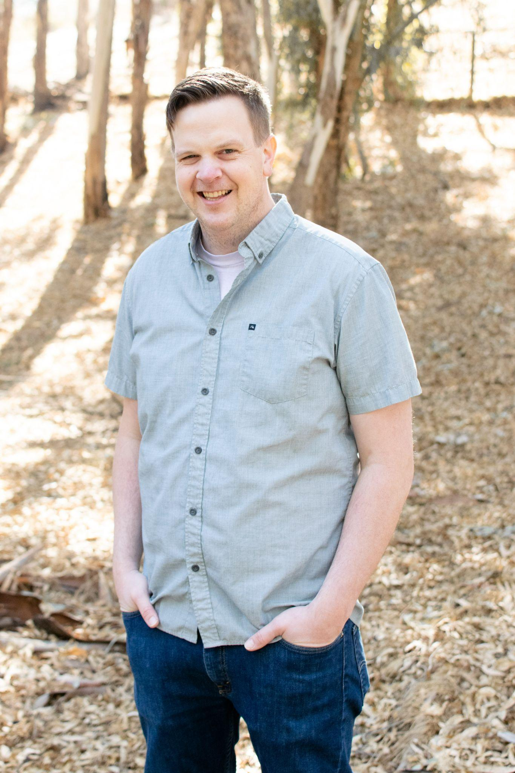

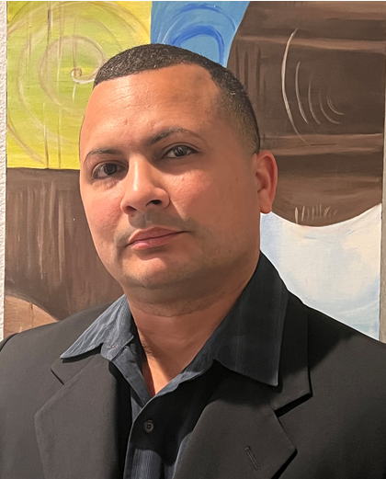

____________________________________________________________________________

**Team: Rules, Norms, Expectations:**

* On time: Team members will arrive on time. If team members are unable to arrive on time, they will make an effort to notify the team. Absences for emergencies will be excused so long as the team and Professor Wu are made aware of them.
* Respectful: Team members will act respectfully towards each other and bullying, harassment, and similar forms of disrespect are prohibited.
* Willing to learn: Each team member will be asked to learn new information and skills to complete their work on this project. This learning will both be inside and outside of the classroom.
* Open to help: If a teammate is struggling with an aspect of their work, they are expected to ask for help. Similarly when asked for help, team members are expected to assist their teammate so long as they are reasonably able.
* Communication: General team communication will be done via the group’s Discord channel.
* Quality: Team members are expected to finish their tasks at the best quality possible, satisfying the client. If work is considered poor quality by the rest of the team, it will be redone.

____________________________________________________________________________

**Goals:**

* “Build a new machine learning algorithm.” (Wesley Schultz, Feb. 1st)
* Obtain Google Street images, in order to start the development of their processing through a pre-trained, or a new, model, for our specific litter use case.
* Process Google Street images with proper annotations
* Consider utilizing open-source APIs to process the Google Street images.
  + Read the documentation from these open-source projects.
* Detect the litter in Google Street images.
  + Count the amount of litter.
  + Categorize the litter (e.g. Bottle, Paper bag), alongside other metrics.
  + Show the detection accuracy (e.g. 90% sure this is a Plastic bottle-Litter).
* Collate the output data/results.
* Figure out the input/output pipeline with the retrieved Google Street images and their resulting litter data.
  + Solidified, running on a server for the Web App team.
  + Formats synced up with the Web App team.
* Make the results available to the Web App team.

____________________________________________________________________________

**Questions:**

* **Noah (Team/Scrum Leader):**
* Litter Rating after detection? Is it a requirement?
  + It seems to have been a feature in previous litter detecting ML group projects. However, I don’t believe Dr.Schultz mentioned that feature being requested in this new ML algorithm.
* Who is responsible for the training dataset?
  + We have a small set we collected to train with now, but the process could use a bigger dataset. Will we have to collect more? Or is that something the Web App team will provide?
  + If we have to collect more, could we possibly use the Google Street image datasets of a previous semester?
* As far as we are concerned, as the ML team, our end goal is to build a litter-detecting ML algorithm that will be usable to the Web App team and their Google Street images, yes?
  + Any other tools, or parts, needed for the Web App team, is of no concern to us to prepare right? (e.g. Like a database - though you already told us no for that specific part.)
* As you have told us in a previous meeting, Dr. Schultz is willing to provide us a team of students who would annotate the Google Street images. However, do we need to provide them the specifics for the labeling (e.g. Plastic bottle, Paper bag), rather than just pointing out if there’s litter or not?
  + Or will Dr. Schultz himself cover that base? (Is that something we need to discuss with him?)
* Again, as you have told us in a previous meeting, Dr. Schultz is willing to provide us a team of students who would annotate the Google Street images. We are currently in the process of finding a software they can use for such a task, but is there any other software that we should prepare/get familiar with?
  + Not just for Dr. Schultz’s students, but for us as well?
* **Jordan (Documentation/Training):**
* How many categories will be required in the final project?
  + Do we have a list of categories that we will be annotating with?
    - Can it be broken down by glass, paper, cardboard, plastic and other?
    - We are planning to meet with the web app team tomorrow and such a list is something we can present to them to help with integration.
* **Miguel (Programmer):**
* After talking to Professor Wu, he wants us to focus on identifying general trash in phase I instead of working to categorize trash into attributes such as can, plastic, aluminum, paper, etc.
  + Can we work towards this goal?
  + If not, then What would be the attributes?
* I know that Jared is our customer but I would like to know his level of involvement in the project.
  + What is Jared’s scope in the project?
  + Is he helping us develop the machine learning algorithm?
  + What is the level of involvement Jared has in the project?
* One of our requirements is to have our environment ready. If we are running the machine learning algorithm in a private server instead, we must have access to it.
  + We know that we have access to the free version of google cloud but is it enough to train and test?
  + When can we start using the Private server?
* Another requirement that came in at the last minute was the application to run the Image Annotation.
  + Do we need to provide software for annotations?
  + Should we just focus on developing the program with the output from the web application team?
* **Keith (Programmer):**
* Can we run VIA Project Server with VIA3 on our Google Cloud instance or would there be too much traffic if Dr. Schultz’s students tried to annotate at once.
* Can we use already annotated images from the TACO Dataset that have a street/gutter background.
* Rather than focusing on what type of trash there is, should we instead focus on how we can improve the efficiency of our Litter Detection over the previous team’s process.
  + What benefit do we get from knowing what type of litter there is?
* **Juan (Project Manager):**
* What could be a reasonable deadline If Shultz’s students are the ones to annotate those images?
  + This would help us in updating our timeline so we can plan out when we have that data set available to use.
  + If there was a need to request more images. In case some images have issues with working with the ML implementation would it be appropriate to ask Dr.schultz students.
* Communication with those responsible for annotating images.
  + In case of any confusion would we communicate with Schultz. Who would be in charge of choosing those images?
  + Like for example choose images that vary in amounts of trash.
  + Some google street images might just be a clean sidewalk with a building wall beside it.
* Once we get to the training phase for the machine learning implementation would Mob Programming be advisable?
  + I don’t happen to have a good idea to split up the work if the program won’t have as many features as compared to the UI team. Would like to know the best way that we can work on the project as a team.
* Would the Confidence level of determining litter be similar to the Litter rating? (If Prior answer is not clear)
  + Mentioned by Noah of a prior litter rating feature.

____________________________________________________________________________

**Reiterate Goals with newly learned requirements.**

**Meeting Adjourned.**